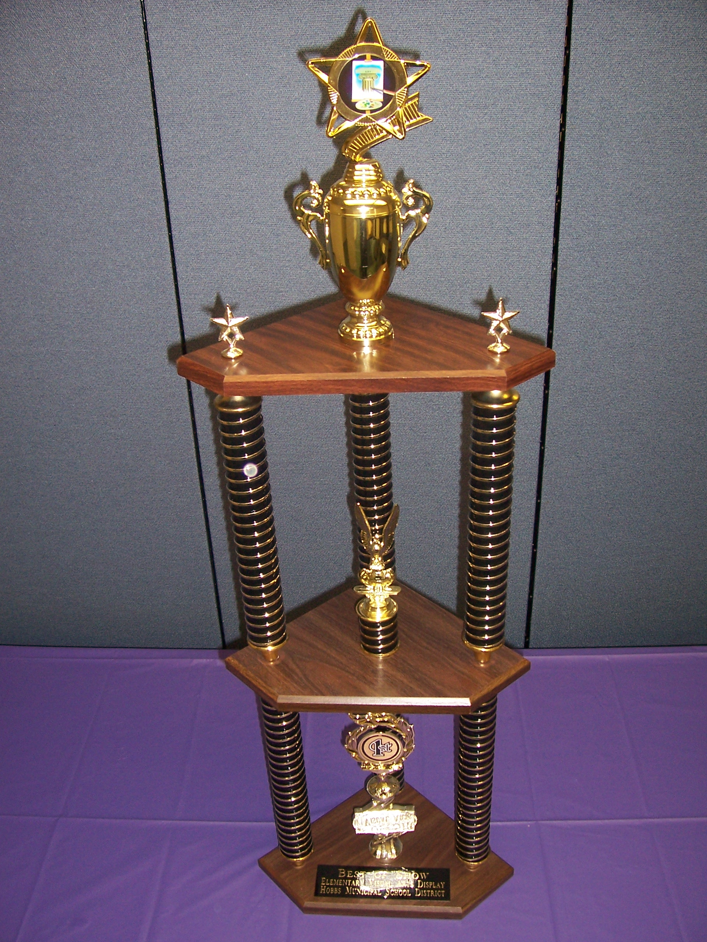
2013 District Art Fair Procedures

The judges will visit your schools April 29th – April 30th and judge the artwork in your hallways along with judging your actual hallways.

The judges will judge 5 major areas for the individual artwork and school presentation:

- Creativity
- Craftsmanship
- Neatness of Work
- Overall Presentation
- Proper Use of Materials

The school that has the top three most impressive and creatively displayed hallways that week will be awarded a First, Second or Third Place trophy respectively at the School Board Meeting at 6:00 pm on Saturday May 21st 2013.

________________________________________________________

The individual ribbon winners will be framed and displayed at the Center for the Arts on May 11th through May 24^{th.}

We will need a few procedures in place to help us get the ribbon winners from the Center for the Arts for display and back to your school by the end of the year.

There will be 1st Place Ribbon given to one student in every teacher’s class, therefore only artworks to be judged should be placed in the hallway near the teacher’s room.

Only individual artwork (not group work) will be judged.

Artwork to be judged should be no larger than 22” X 28”.

Due to time limitations please avoid conversations with the judges.

Make sure that you have on every student’s artwork on the back of the artwork or mat.

Student’s First and Last Name Printed

Teacher’s Name

Grade Level

School Name

This will help us get the student’s name spelled correctly on the program for the Center for the Arts reception May 11th and on the back of their ribbon.

The People’s Choice Award will be chosen from the 1st Place ribbon winners. The ballots will be at the Center for the Arts front desk so the ribbon winner, their parents, and fans will have plenty of chance to give their two cents worth on who they think is the best in each grade level for the entire district. Those ballots will be tallied and the People’s Choice Trophies will be given to one student in each grade.

Thank you for all the hard work you have done and are continually doing to prepare for this art show. It takes all of us to make a District Wide Art Show happen. If you have any questions do not hesitate to e-mail me at ledgerwoodt@hobbsschools.net .

